**CS673 Software Engineering**

**Team 3 - StockPickers**

**Software Test Document**

| Team Member | Role(s) | Signature | Date |
| --- | --- | --- | --- |
| Sylvie Xiang | Team Leader | *Sylvie* | 05/24 |
| Duy Nguyen | QA Leader | *Duy Nguyen* | 5/26 |
| Serguei | Design Leader | *Serguei* | 6/12 |
| Jing Tian | Configuration Leader | *Jing Tian* | 5/14/22 |

**Revision history**

| **Version** | **Author** | **Date** | **Change** |
| --- | --- | --- | --- |
| **V1** | Sylvie, Duy, Jing | 05/28 | Initial |
| **V2** | Sylvie, Duy, Jing | 06/08 | Add more unit, integration, and manual testing on new features.  Changed integration test command. |
| **V3** |  |  |  |

Testing Summary

Manuel Tests Reports

Automated Testing Reports

Testing Metrics

References

Glossary

# Testing Summary - Duy + Sylvie

Unit tests will be written for key functions of the program. Every team member will help with unit tests but the QA leader will be responsible for developing an adequate amount of unit tests to validate through integration tests. QA leader is also responsible for running unit tests and integration testing.

* + Unit Testing
    - URL
    - Get and Post requests for each view
    - Card.JS methods for front-end
  + Integration testing
    - Tests use Selenium webdriver
    - Test selecting a stock without forecasting and plotting the chart for selected stock all work as intended
    - Test selecting a stock with forecasting and plotting the chart for selected stock all work as intended
    - Test selecting and deselecting favorite stock both work as intended
  + System Testing
    - Site navigation to make sure the app is working properly.
    - Test various stocks to make sure price and forecast data is displayed
    - Test print functionality

# Manual Testing Report - Jing + Duy

All Manual Test Reports are stored at the link below.

[Manual Test Reports](https://docs.google.com/document/d/1ulR8VQDvu6ybvlsn-DFFNZ7oX5rbXkr0P-g-XdpbCVg/edit#)

# Automated Testing Report - Sylvie

Test framework with Selenium was used to add integration tests and automate the testing. Tests reside in the [integration_tests/tests folde](https://github.com/BUMETCS673/group-project-team3/tree/main/stock_getter/integration_tests/tests)r and can be ran with command:

* npm test **/*.test.js

Detailed instructions about how to run the integration tests and information about the code used can be found in the [README.md](https://github.com/BUMETCS673/group-project-team3/blob/main/stock_getter/integration_tests/README.md) file in the integration_tests folder.

Here is an example of the test screenshot:

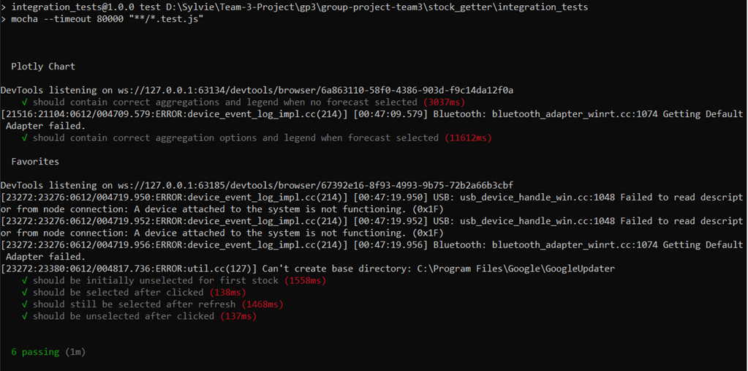

There was a [bug](https://github.com/BUMETCS673/group-project-team3/issues/23), showing forecast data in the legend when there is no forecast selected, displayed as below:

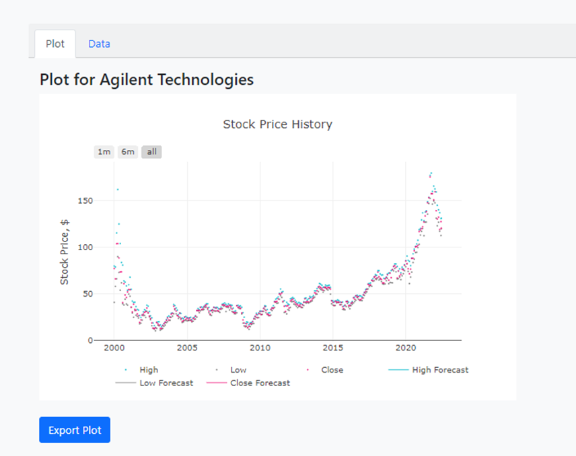

After fixing the bug:

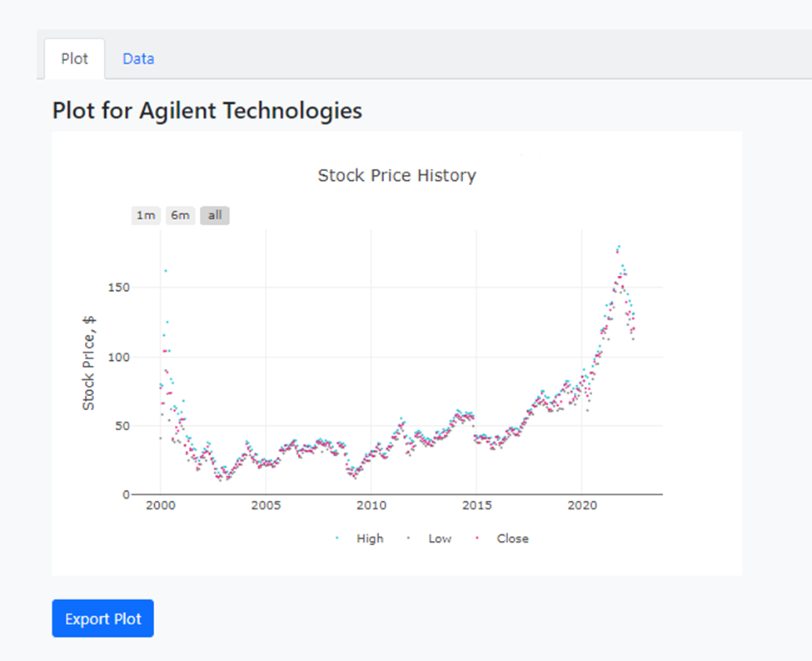

# Testing Metrics - Duy

| **Metric Name** | **Description** |
| --- | --- |
| **Cost** | # of person hours used |
| **Test case pass** | % of unit test passed/total unit test |
| **# of Feature completed** | Number of planned features that are completed |
| **Customer Rating** | MFA of completed program to be sent out to customer for rating via SurveyMonkey. Targeted customer to gather survey from will be fellow students of CS673 Summer1 |

# References

# Glossary

MFA - Market Feedback Analysis, a survey that tracks performance of a process based on end user(market) opinion.